**EX NAME: Implement data analysis applications using Pig**

1. Write a Pig Script to split customers for reward program based on their life time values.

If Life Time Value > 100 and <= 2000 => Silver Program.

If Life Time Value > 20000 => Gold Program.

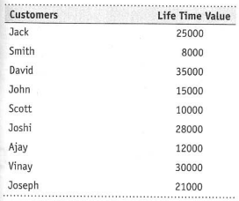

1. Create a data file for below schemas.

Order : Order_ID, Customer_ID, ItemID, Item_Name, Order_Date, Delivery_Date, Quantity, Cost

Customer: Customer_ID, Customer_Name, Address, City, State, Country.

* 1. Load Order and Customer Data.
  2. Write a Pig Script to determine number of items bought by each customer.
  3. Merge both relations and write it in a new file.
  4. Use map data type to create <Order_ID, Customer_Name>

1. Create a file which contains bag dataset as shown below.

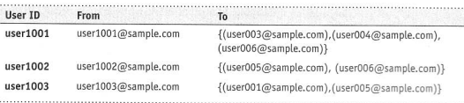

* 1. Write a pig Latin Statement to display the names of all users who have sent emails and also s list of all the people that they have sent the emails to.
  2. Store the result in a file.

1. Use piggy bank function to execute eval_functions
2. Create a user defined function in any language and use it in Pig Script
3. Execute in both local and mapreduce mode.